

Table of Contents



Internet …………………………………………………….. 2

Connecting to Andover Wifi

PANet / Canvas …………………………………………… 3

I can’t log in to Canvas!

I can't check my schedules!

How do I change my password?

I forgot my password

Printers ……………………………………………………... 5

My wireless printer won’t work

My wired printer won’t work

Printing on campus

PrintOn doesn’t load

Printing a double sided document

Hardware …………………………………………………... 7

My charged iPad/iPhone won’t turn on, or is “frozen”

My charged Android device won’t turn on, or is "frozen"

Software ……………………………………………………. 8

Getting Microsoft Office for free

Setting up emails on your phone

Internet



Connecting to Andover Wifi

Find “PASTUDENT” in your computer’s network list. For the username and password, use the same credentials that you use to log into PANet and Canvas.

PANet / Canvas



I can’t log in to Canvas!

If your screen looks something like this:

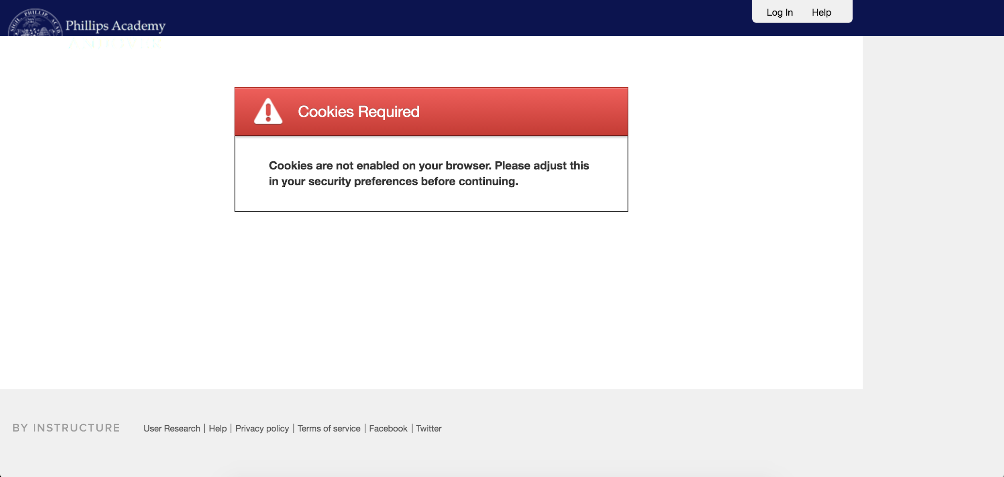

Try going to PANet, and then logging in, and clicking the link to go directly to Canvas. If this still doesn’t work, you will need to clear your cookies. Go to your browser history, clear history, and make sure you select “cookies.” Clear it and try logging back into Canvas.

I can’t check my schedules!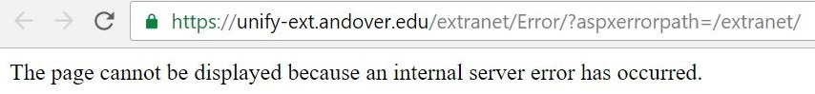

Try right clicking on the schedules link in PAnet and selecting "open in new incognito/private window." Enter your PA credentials in the new window that opens.

The other, longer-term solution is to clear your cookies. Go to your browser history or settings, clear history, and make sure you select “cookies.” Clear it, restart your browser, log into PAnet, and try opening your schedules again.

How do I change my password?

Go to **mypassword.andover.edu** and follow the instructions there.

I forgot my password

Go to **mypassword.andover.edu** and click on “Reset my Password.” Answer your security questions, and you should get your password back. If you don’t know your security questions, you need to go to the OIT help desk in the PACC (in the basement of the library).

Printers



My wireless printer won’t work.

Unfortunately we **cannot** help you with this problem. This is because Andover’s Wifi runs on a different security protocol than what most wireless printers are designed to run on, so your printer will not work.

My wired printer won’t work.

For your wired printer to work, you need to have the correct drivers for the printer installed. A CD or a link with the driver should have been provided when you purchased the printer, and all you need to do is download and install the driver. If you misplaced these, try searching your printer model name online to find drivers for it.

Printing on campus

If all of the printers you touch do not work, there is another option! Head over to **printon.andover.edu**, login, and select a printer to start printing. Just head over to the selected location and pick up your prints.

PrintOn doesn’t load

PrintOn will only load properly if you are on Andover’s Wifi network. If it still doesn’t load, then PrintOn’s servers are probably down (This is highly unlikely though).

Printing a double-sided document

If you are using PrintOn, the only printer that supports double sided pages is “owl-lobbymain.” On page 3, there will be an option that says “duplex.” Here you will be able to select your double-side printing choices. If you are using your own printer, open up the printing panel. It should look something like this:

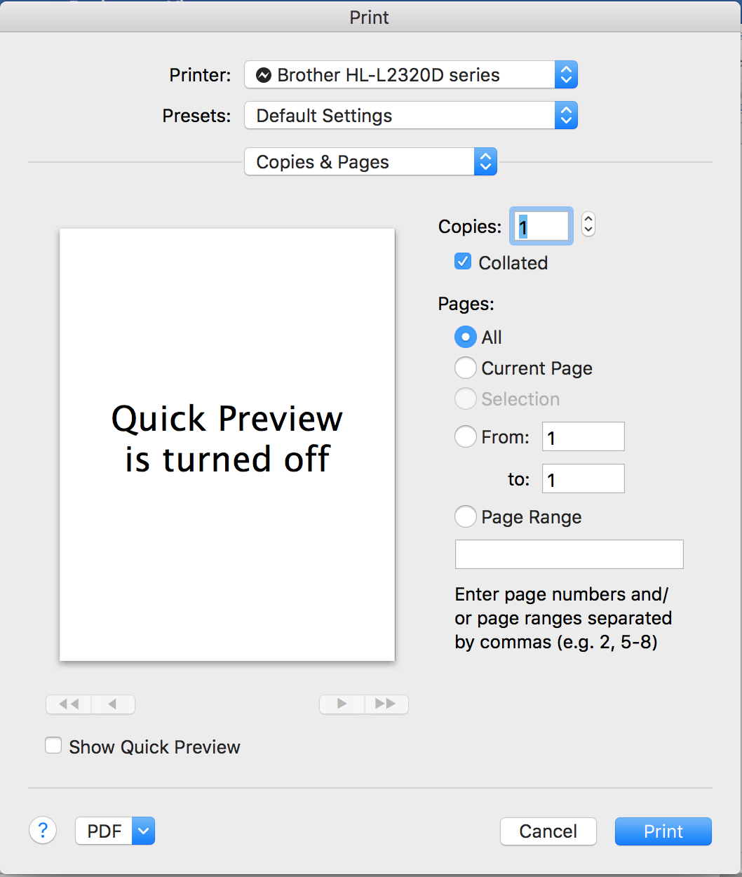

Select “Copies & Pages” and go down the dropdown to select “Layout.” There will be an option called “two-sided,” which you can change to print double sided.

Hardware



My charged Ipad won’t turn on

Try to do a hard reset. Unplug the ipad from your charger, and press and hold the power button and the home button at the same time for at least 10 seconds until the Apple logo appears.

Software



Getting Microsoft Office for free

As an Andover student, you are able to get the latest version of Microsoft office for free. Go to **portal.office.com/start?sku=student** and enter your Andover email to get started.

Setting up emails on your phone

Download the “Outlook” app onto your phone. Add an “Exchange” email account, and input your Andover email and credentials.